**Lab 6: Android AbsoluteLayout**

# **Introduction**

Using x/y coordinates, an Absolute Layout allows you to specify the precise placements of its offspring. Compared to other types of layouts that do not contain absolute placement, absolute layouts are less adaptable and more difficult to maintain.

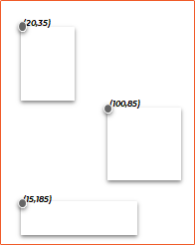

|  |  |
| --- | --- |
| Attribute | Description |
| id | Used to identify uniquely |
| layout_x | Used to specify X Coordinate |
| layout_y | Used to specify Y Coordinate |

**Let’s get Started**

You will be guided through a series of easy stages in this exercise to design your own Android application utilising Absolute layout.

**Step 1: Create a New Project in Android Studio as shown below**

**Step 2: Select Empty Activity as shown below**

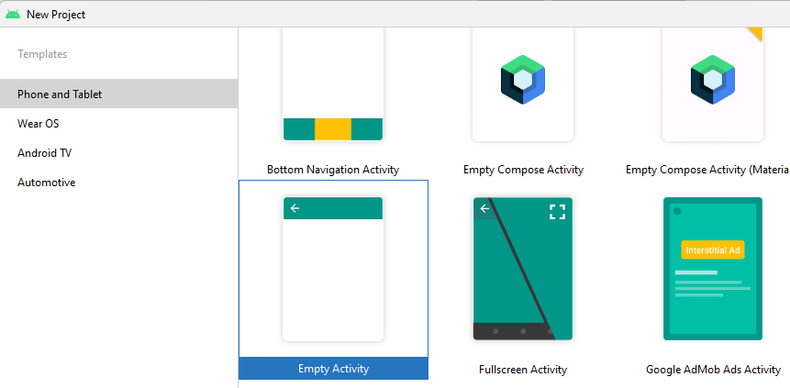

**Step 3: Provide a Project Name as shown below**

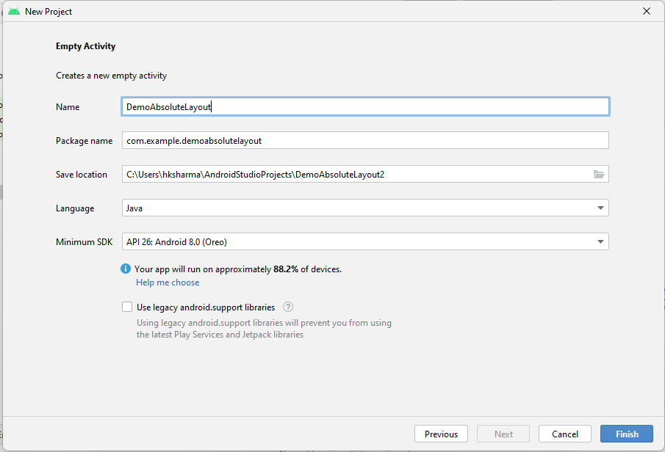

**Step 4: Update MainActivity.java as per the code given below**

**package** com.example.demoabsolutelayout;  
**import** androidx.appcompat.app.AppCompatActivity;  
**import** android.os.Bundle;  
**public class** MainActivity **extends** AppCompatActivity {  
  
 @Override  
 **protected void** onCreate(Bundle savedInstanceState) {  
 **super**.onCreate(savedInstanceState);  
 setContentView(R.layout.***activity_main***);  
 }  
}

**Step 5: Update activity_main.xml as per the code given below**

*<?***xml version="1.0" encoding="utf-8"***?>*<**AbsoluteLayout xmlns:android="http://schemas.android.com/apk/res/android"  
 android:layout_width="fill_parent"  
 android:layout_height="fill_parent"**>  
  
 <**Button  
 android:layout_width="100dp"  
 android:layout_height="wrap_content"  
 android:text="OK"  
 android:layout_x="50px"  
 android:layout_y="361px"** />  
  
 <**Button  
 android:layout_width="123dp"  
 android:layout_height="wrap_content"  
 android:layout_x="127dp"  
 android:layout_y="361px"  
 android:text="Cancel"** />  
  
</**AbsoluteLayout**>

**Step 6: Check Output on Android Emulator and it should look like as given below**

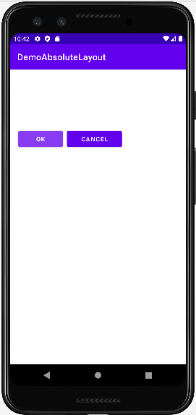

**Voila!!** We have successfully completed this lab.